CAR FOR SALE
CALL Maria or Alisa
@
662-434-6052
2020 Nissan Altima

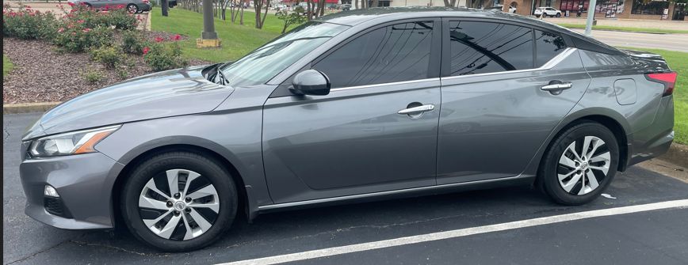

Important Information
Mileage: 81308
Color: Gray
Additional Accessories/Info:
- Sedan 4 Dr
- 2.5L
- Front Wheel Drive
Condition: AS IS
Price: $17,600
or Best Offer

