CAR FOR SALE
CALL Maria or Alisa
@
662-434-6052
2019 Nissan Sentra

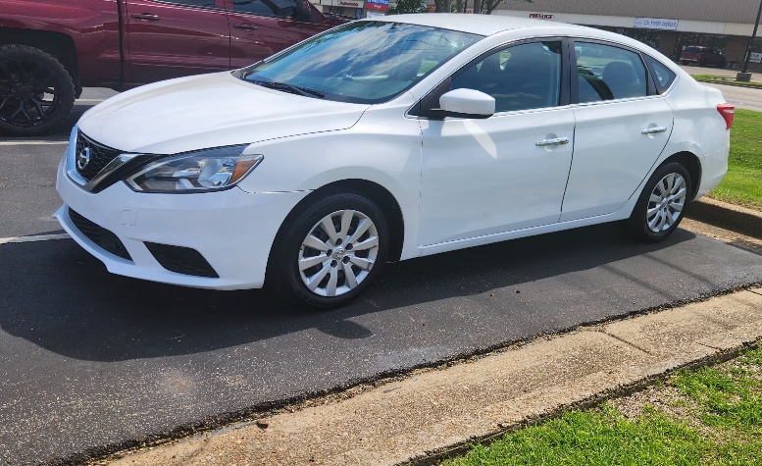

Important Information
Mileage: 65,149
Color: White
Additional Accessories/Info:
- Sedan 4 DR  - 1.8L  - Front Wheel Drive | - Power Windows, Locks, Steering
Condition: AS IS
Price: $15,000
or Best Offer

